

NOVAC TECHNOLOGY SOLUTIONS

User Manual

Document Version No.: 1.00

Revision History
Version No | Reason For Changes | Author | Approver
0.01 | Draft | Anurag Kumar
1.00 | Reviewed & Approved the User Manual | Anurag Kumar | NIJANTHAN PL

Table of Contents
1. Introduction 4

2. Policy schedule Interface 4

Introduction

As per the requirement, new validation required in the Policy schedule interface screen for Motor Fleet product.
- Guidelines, circulars, instructions and directions released from time to time by Philippines Insurance council.

1.1 Functional Overview

In the policy schedule interface, system should check and raise the validation if master policy does not have the child policy details

Policy schedule Interface

- The system should verify if the child policy has been uploaded against the corresponding master policy when generating a policy schedule in the Policy schedule interface screen for the Motor Fleet product. If the child policies are not uploaded against the master policy, the system should show an error message as "Child policy is not uploaded for this Master policy" and restrict to generate the policy schedule document in the Policy schedule interface screen.

- Click on the policy schedule screen and enter the details and click on print button.

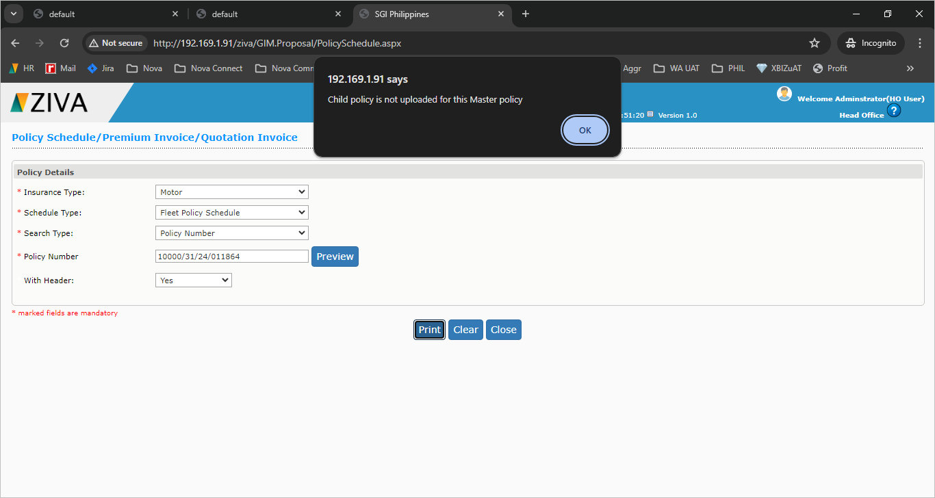

- If any endorsements was done against the master policy, the system should ensure that the same endorsement was done to the child policy also. If the child endorsement is not done, system should raise the error message “Child policy endorsement is not completed. Please do the child policy endorsement” when attempting to generate the endorsement schedule after the endorsement for Motor Fleet.

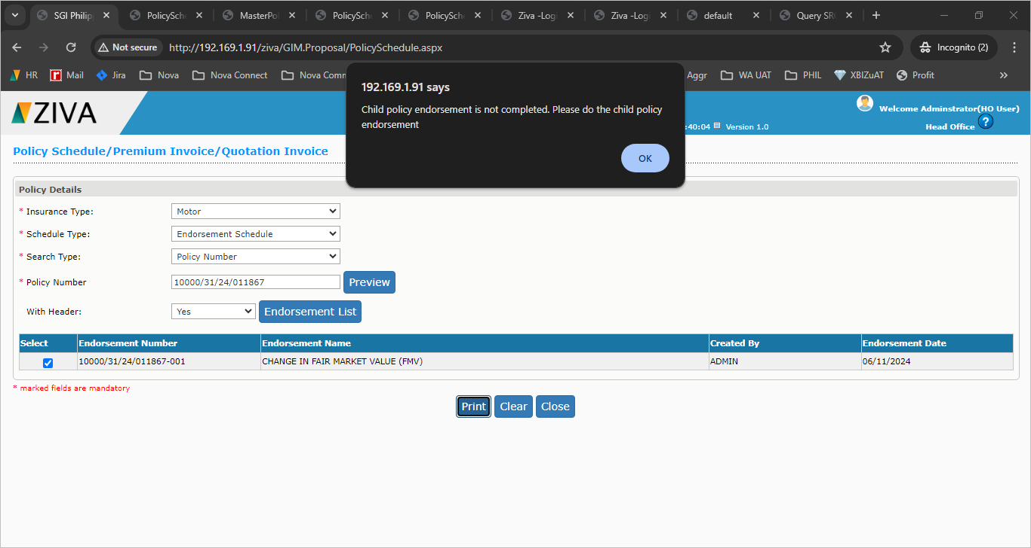

Click on close button to close the window.

